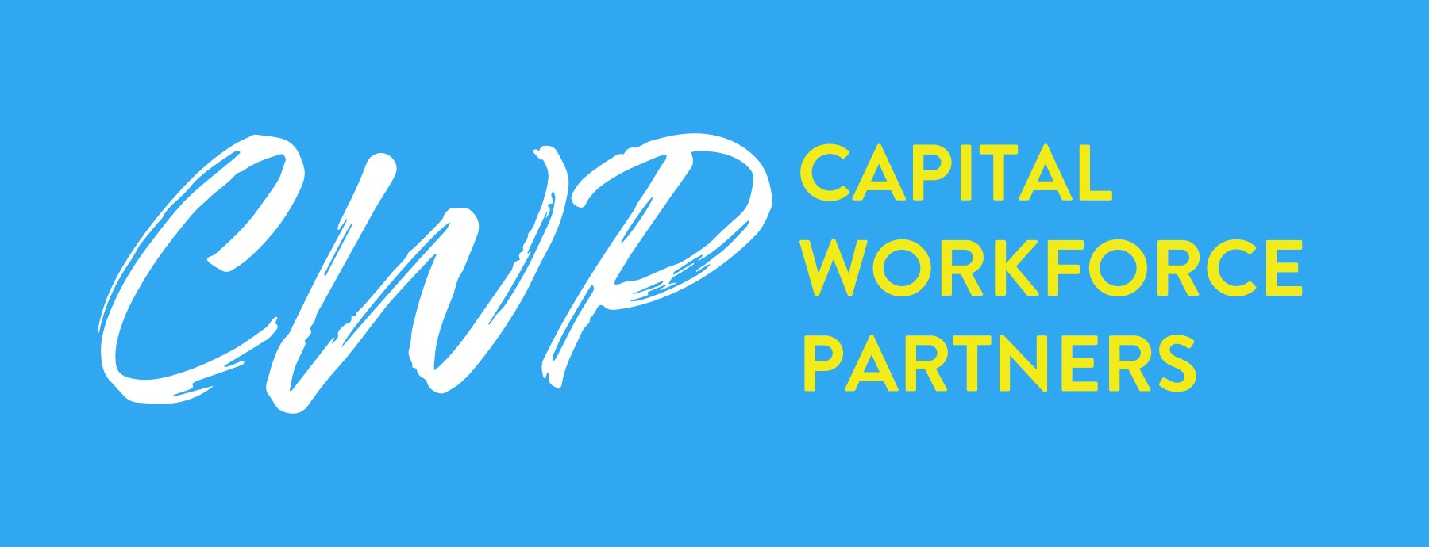
2021 Summer Youth Employment and Learning Program Documentation Guide
Documentation and Paper Files
Every applicant must have a paper file containing copies of documentation verifying eligibility. CWP will conduct onsite monitoring of applicant files and eligibility determination throughout the intake period. Below is a list of the most common documents for each eligibility criterion. Keep in mind that some documents can cover multiple categories, as long as the information is explicit. This is not a complete list of acceptable documents – if you have a question about a particular document, contact CWP.
Eligibility | Definition | Documentation
Application | Must have a completed and signed 2021 SYELP application | • SYELP 2021 Application  Printable only from Webauthor
Income | Must meet one of the income criteria on the self-attestation form or be a member of a family whose income is equal to or less than 185% of the federal poverty level  Applicants who attend a universal feeding school do not need separate documentation of low-income status | - Income Self-Attestation Form (signed by parent/guardian)  - Letter from the Department of Social  Services  - EMS printout  - Letter from the Department of Children and Families (if foster child in DCF custody)
Work Authorization | Must be eligible to work in the United States  Do not complete the USCIS Form I-9,  Employment Eligibility Verification, until the  applicant starts the program | - US passport  - Alien registration card  - School or state photo ID and social security card or US birth certificate See Form I-9 “Lists of Acceptable Documents” for guidance
School Status | In-school must be enrolled in secondary school (12th grade or below) at time of application  Applicants who graduated high school in the  2019-2020 academic year are eligible | - Transcript or report card  - School Status Self-Attestation Form (if out-of-school)
Residency | Must be a resident of the North Central Connecticut region | - Transcript or report card  - Utility bill or similar  Name and home address must appear
Age | Must be between 14 and 24 years old as of July 1, 2021  Birthday must be between 7/2/1998 and 7/1/2007 | - Birth certificate  - State or government photo ID  - Transcript or report card  Name and date of birth must appear
Eligibility Determination
Every applicant must have his/her eligibility determined, based on his/her completed application and supporting documentation. An applicant must be categorized as one of the following:
- Hartford resident and low-Income • Regional resident and low-Income
- Hartford resident but not low-Income • DCF
If the applicant does not fall within any of these categories, s/he is ineligible.
Updated 4/12/2021

